15

14

13

12

10

11 and 17



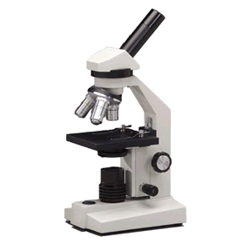

1

2

6

7

5

3

4

8 and 16

9