Only You Can Help Save Sandy!
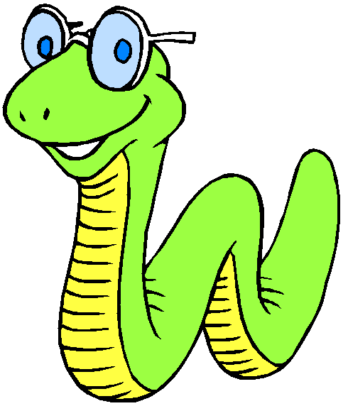

Sandy has been spending her summer boating on the Fox River. However, she’s not too bright (after all, the brains of worms are pretty small). She’s never learned how to swim, and she never wears her life preserver. The worst has happened! Her boat has capsized and she’s stuck! Fortunately, her life preserver is in the boat, but unfortunately she does not know how to reach it without falling off and drowning.

Use the Scientific Method to:

Problem:
How can you and your partner save Sandy using only 4 paper clips? You may not touch Sandy, the boat, or the life preserver directly with your hands.

Materials:
- Gummy Worm
- Gummy “Life Saver” preserver
- 1 Plastic or Paper Cup
- 4 Paper Clips

Procedures:
  - Work with your partner and "Save Sandy".
  - Follow the rules.
    - Sandy, the boat, the life preserver can be touched only with the paper clips. NO HANDS.
  - Develop a data section that includes
    - Diagrams of how you saved Sandy
    - A detailed protocol describing the diagrams.
  - Analyze and Conclude:
    - Analyze and conclude the experiment.
      - This means that you must discuss (tell me what you think) about the difficulty of the task, what other strategies you and your partner worked on before you succeeded, and what you think the critical steps were for solving this problem.
    - Although this is working backwards, and not how scientists normally work, please develop a hypothesis for this lab. (Remember that a hypothesis is an ‘if-then’ statement: if I do this, then this will happen)

- Teacher Notes:
Sandy sits on the inverted cup. The cup sits half-covering the life preserver on the tabletop. No real water is involved.

Name
Date
Science 1 2 3 4 5

Save Sandy Lab

Experimental Question: __________________________________________________________________________________________________________________

Discussion Ideas (Research): Have each person in your group present at least one idea for saving Sandy
- ________________________________________________________________________________________________________
- ________________________________________________________________________________________________________
- ________________________________________________________________________________________________________
- ________________________________________________________________________________________________________

Hypothesis: (If . . . Then . . .) __________________________________________________________________________________________________________________

Materials: Gummy Worm, Gummy “Life Saver” preserver, 1 Plastic or Paper Cup, 4 Paper Clips

Procedure: Record detailed instructions and illustrations for saving Sandy below. You do not have to use 6 steps. If you have more than 6 steps just add the additional steps on the last page of your lab.

 | Written Directions | Illustration
Step 1

Step 2

Step 3

Step 4

Step 5

Step 6

Observations: Explain what happened when you attempted to save Sandy using the procedures above.
___________________________________________________________________________________________________________________________________________________________________________

Analysis:
Explain 2 problems you encountered in this lab.
_______________________________________________
_______________________________________________
Explain 2 ideas or techniques that you think worked well for this lab.
_______________________________________________
_______________________________________________

Conclusion:
Explain which methods you think are best for saving Sandy and why. ___________________________________________________________________________________________________________________________________________________________________________
Describe the effectiveness of your procedure for saving Sandy.

___________________________________________________________________________________________________________________________________________________________________________

